Module Name: Dynamic Controls
Test Case ID: 183
Webpage URL: “https://the-internet.herokuapp.com/ ”

● Scenario ID: 15a
Scenario: Valid Login
Test Steps:
- Open PyCharm IDE.
- Open the existing Python project or create a new project named AutomatedLoginTesting.
- Open the Python file script1.py.
- Verify that Selenium WebDriver is installed in the project environment.
- Import Selenium WebDriver, Selenium locator classes, and exception handling classes.
- Create a Chrome WebDriver object.
- Maximize the browser window.
- Navigate to the Expand Testing login page.
- Verify that the login page is displayed.
- Locate the Username field.
- Enter the valid username practice.
- Locate the Password field.
- Enter the valid password SuperSecretPassword!.
- Locate and click the Login button.
- Wait for the secure page to load.
- Verify that the URL contains /secure.
- Verify that the successful login message is displayed.
- Verify that the Logout button is displayed.
- Display the assertion results in the PyCharm console.
- Handle any Selenium or assertion exception using try-except.
- Close the browser after completing the test.
Screenshots: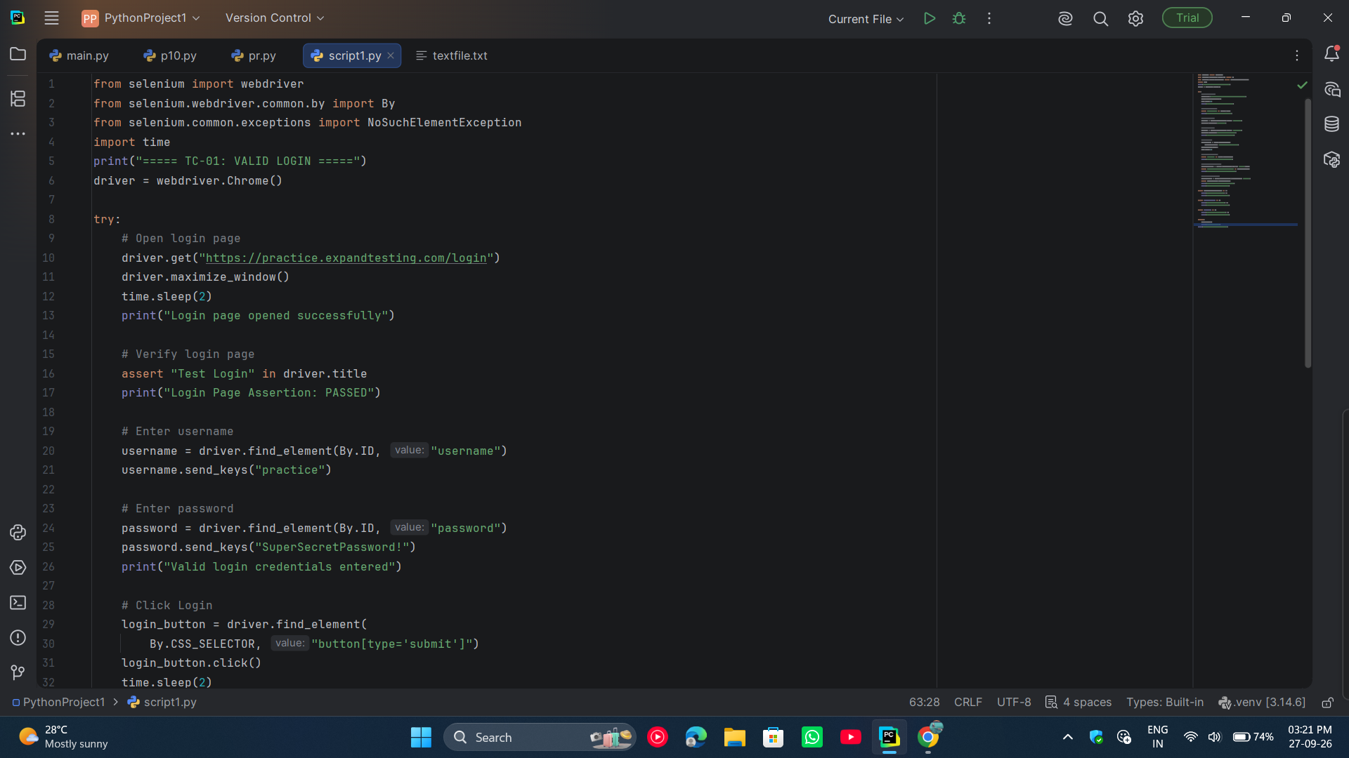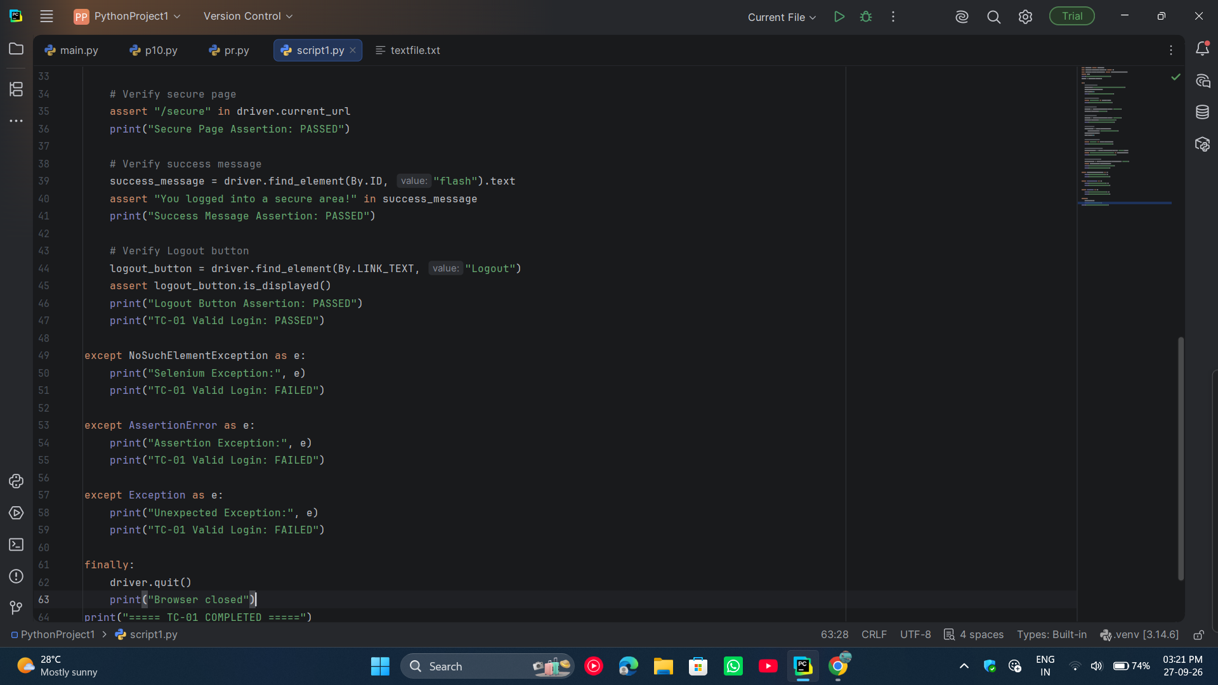

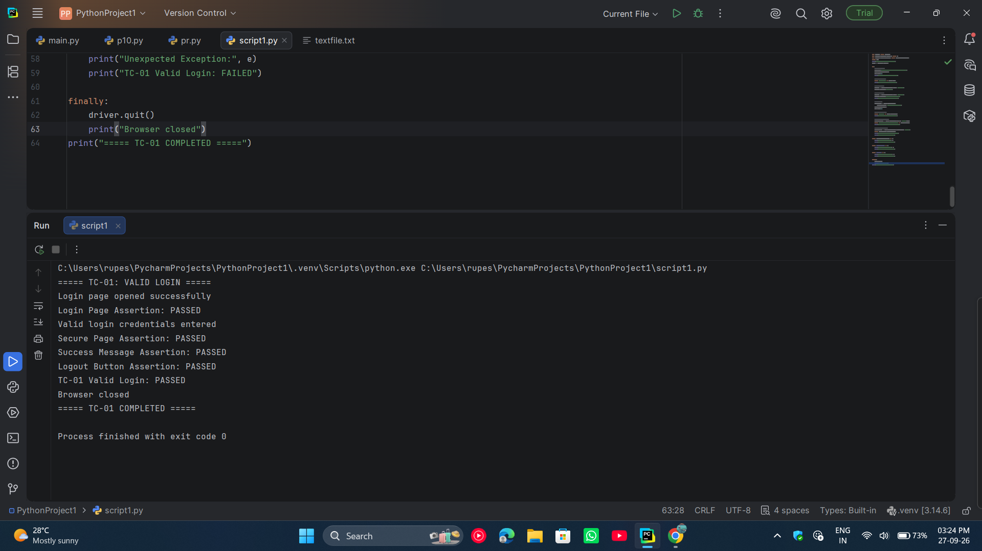

● Scenario ID: 15b
Scenario: Invalid Password
Test Steps:
- Open PyCharm.
- Open the project created for Practical 15.
- Create a new Python file named script2.py.
- Import Selenium WebDriver and the required exception classes.
- Create a Chrome WebDriver object.
- Open the Expand Testing Login Page.
- Maximize the browser window.
- Locate the Username field using its ID.
- Enter the valid username practice.
- Locate the Password field using its ID.
- Enter the invalid password WrongPassword.
- Locate and click the Login button.
- Wait for the login response.
- Verify that the user is not redirected to the secure page.
- Read the message displayed on the page.
- Verify that the message contains “Invalid password.”
- Display the assertion result in the PyCharm console.
- Handle Selenium and assertion exceptions using try-except.
- Close the browser using driver.quit().
- Record the test result as PASS when the expected error message is displayed.
Screenshots: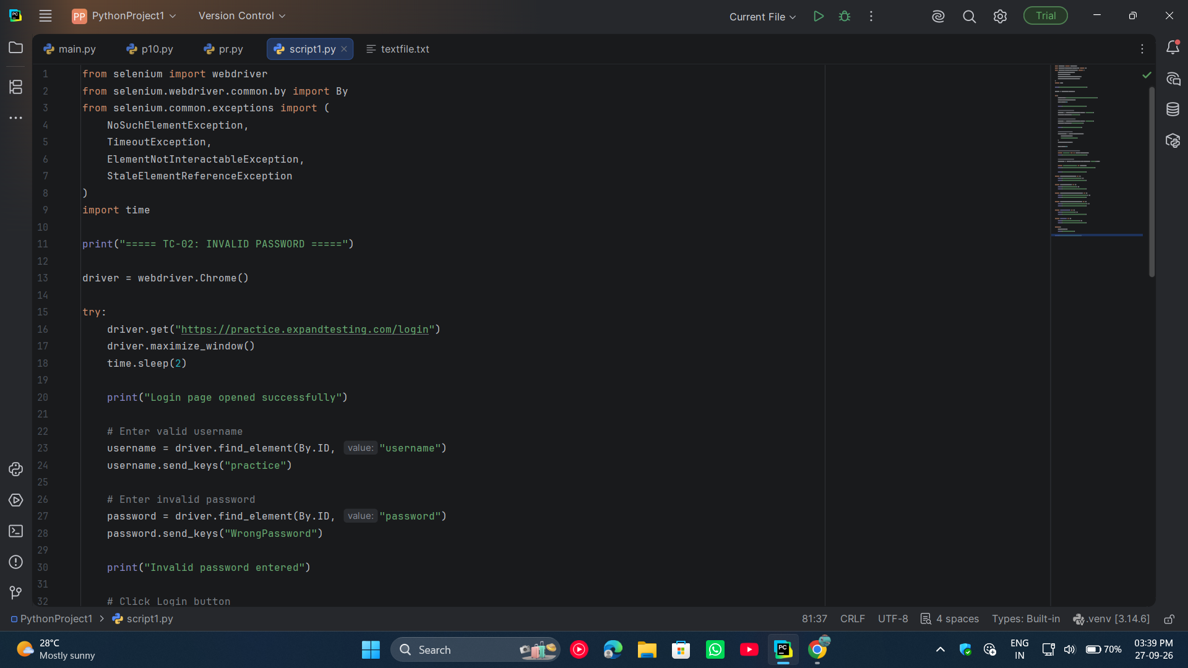

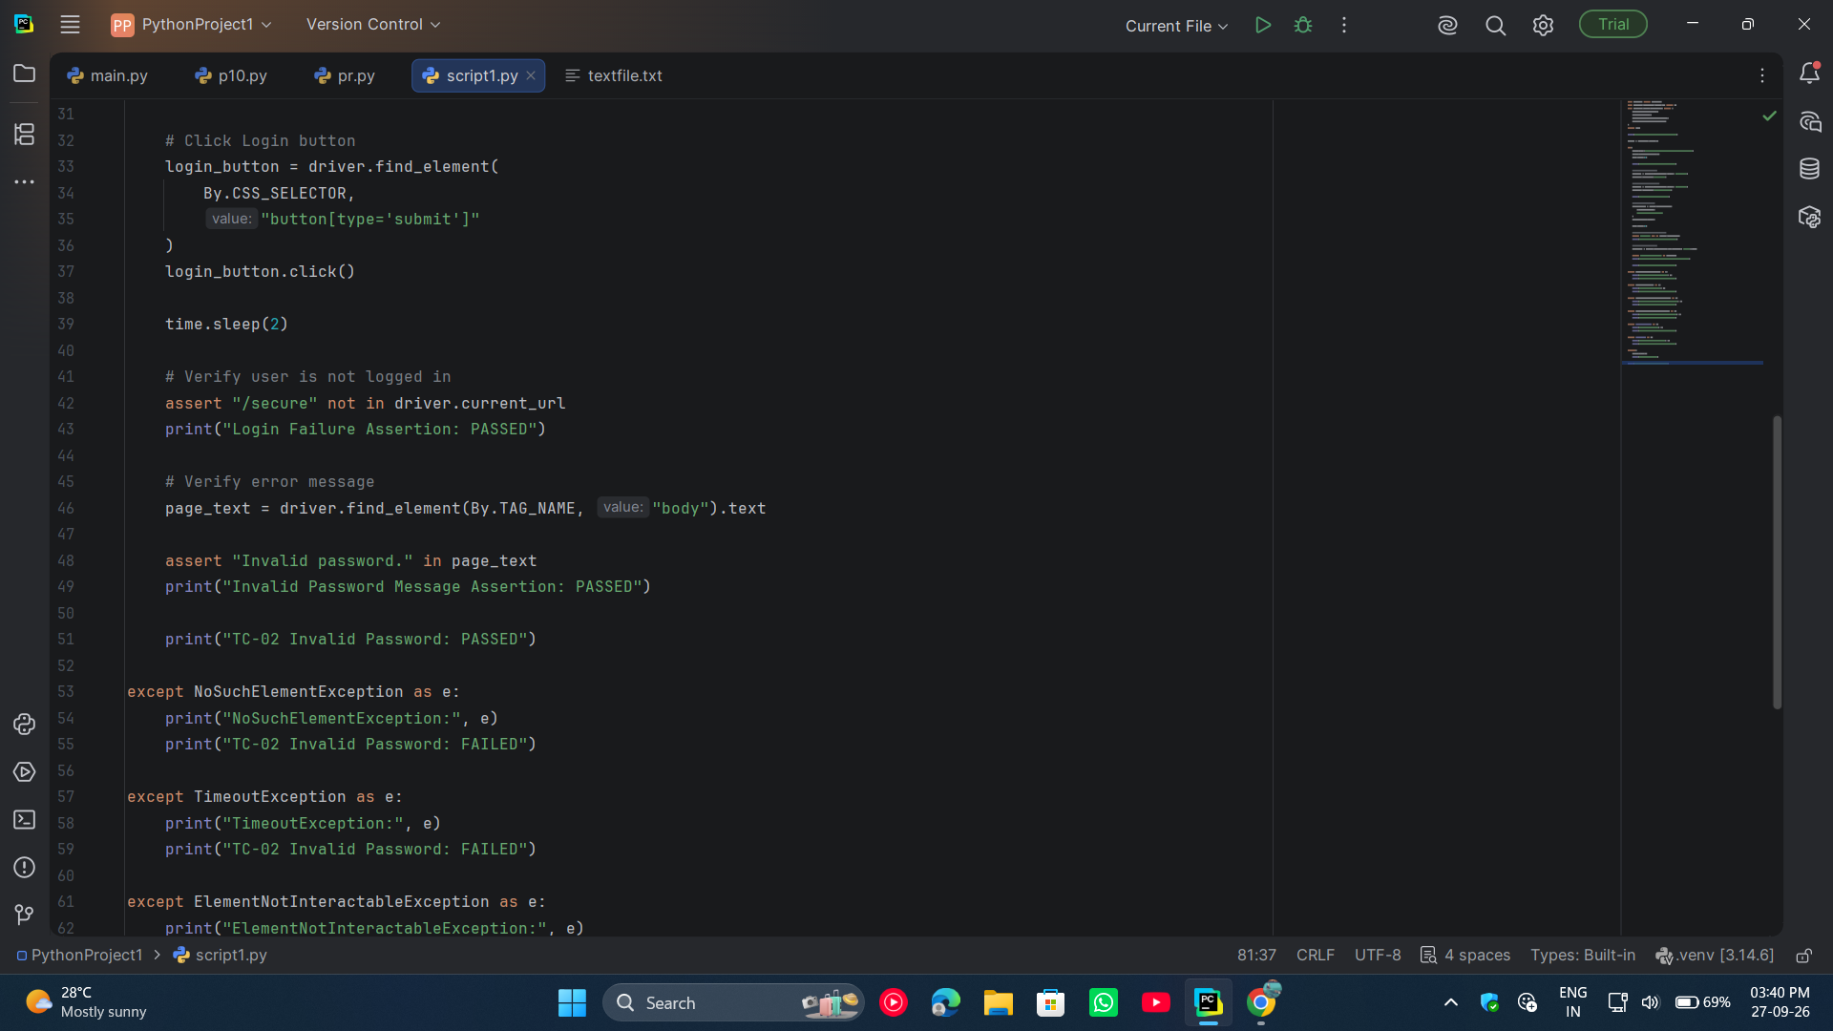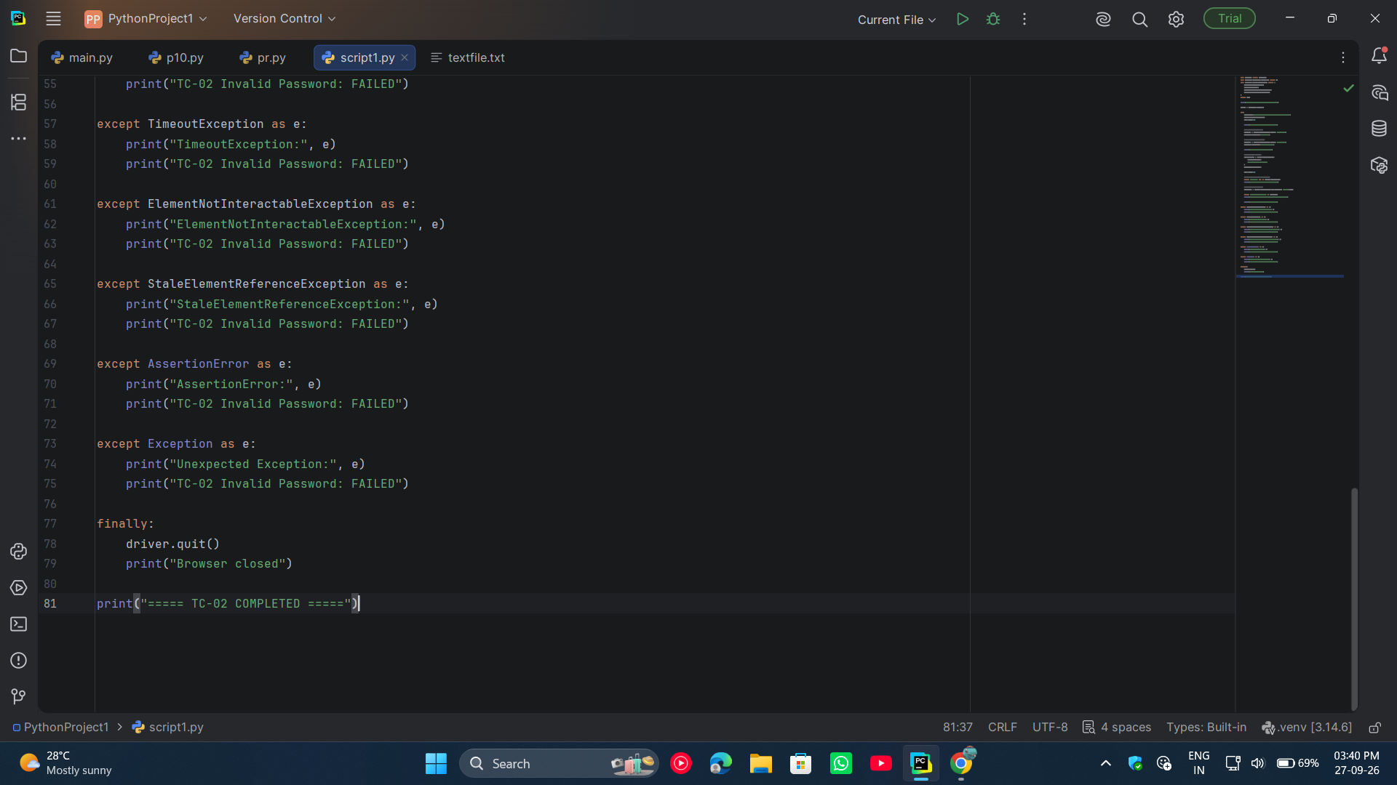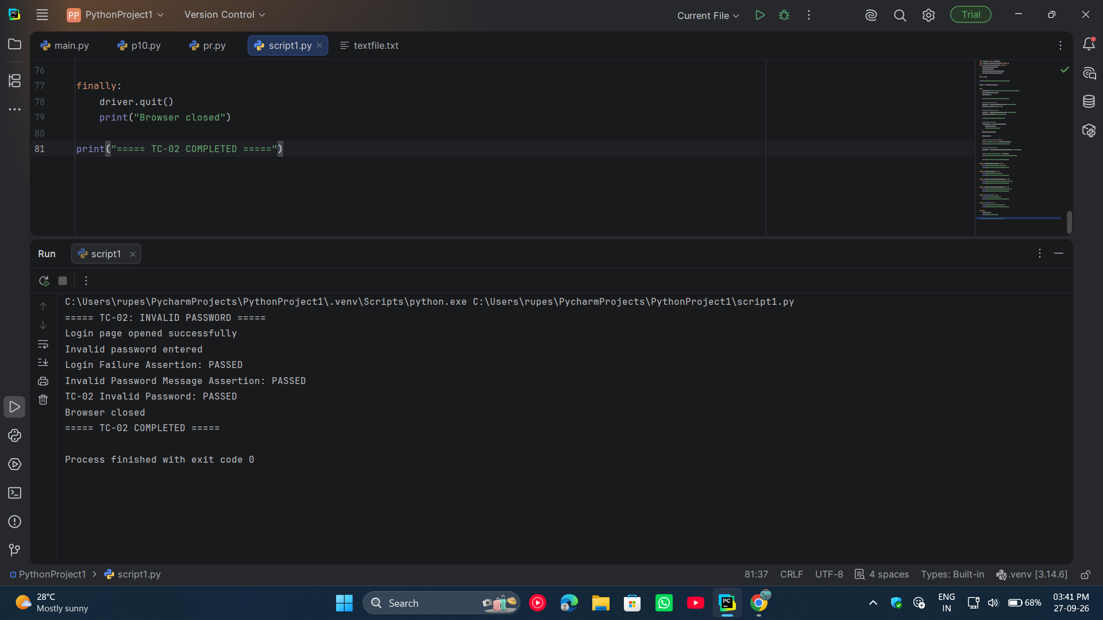
● Scenario ID: 15c
Scenario: Invalid Username
Test Steps:
- Open PyCharm.
- Open your Practical 15 project.
- Create a new Python file named script3.py.
- Import Selenium WebDriver and the required exception classes.
- Create a Chrome WebDriver object.
- Open the Expand Testing Login Page.
- Maximize the browser window.
- Locate the Username field using its ID.
- Enter the invalid username wrongUser.
- Locate the Password field using its ID.
- Enter the valid password SuperSecretPassword!.
- Locate and click the Login button.
- Wait for the login response.
- Verify that the user is not redirected to the secure page.
- Read the message displayed on the page.
- Verify that the message contains “Invalid username.”
- Display the assertion results in the PyCharm console.
- Handle Selenium and assertion exceptions using try-except.
- Close the browser using driver.quit().
- Record the test result as PASS.
Screenshots:
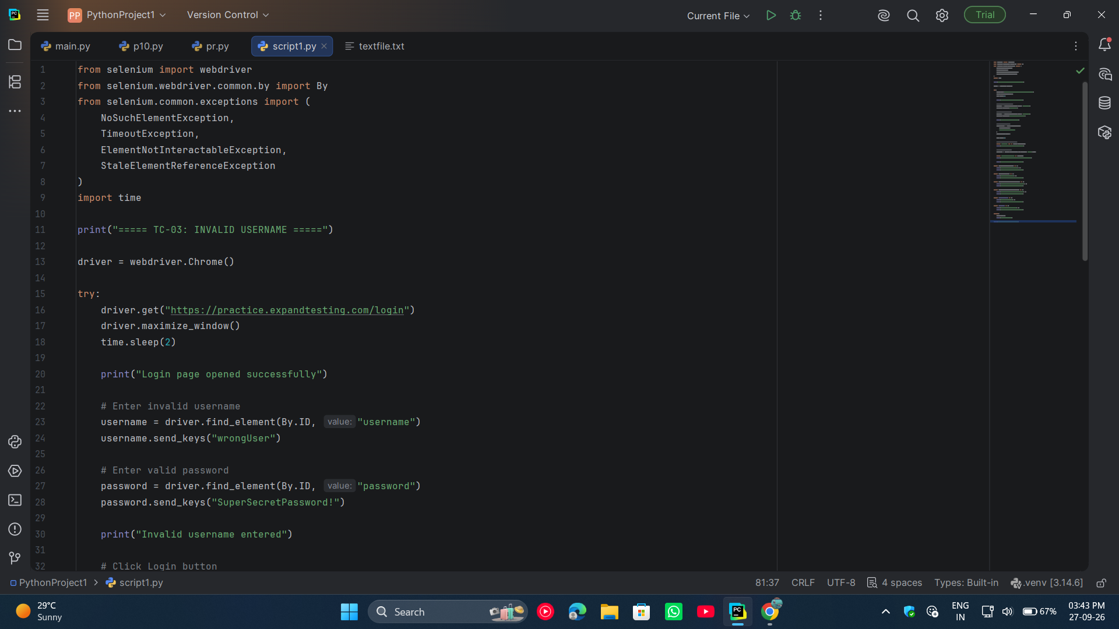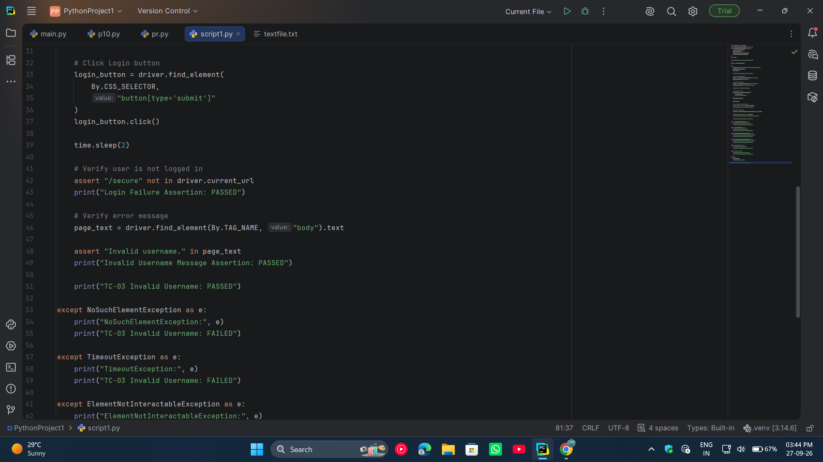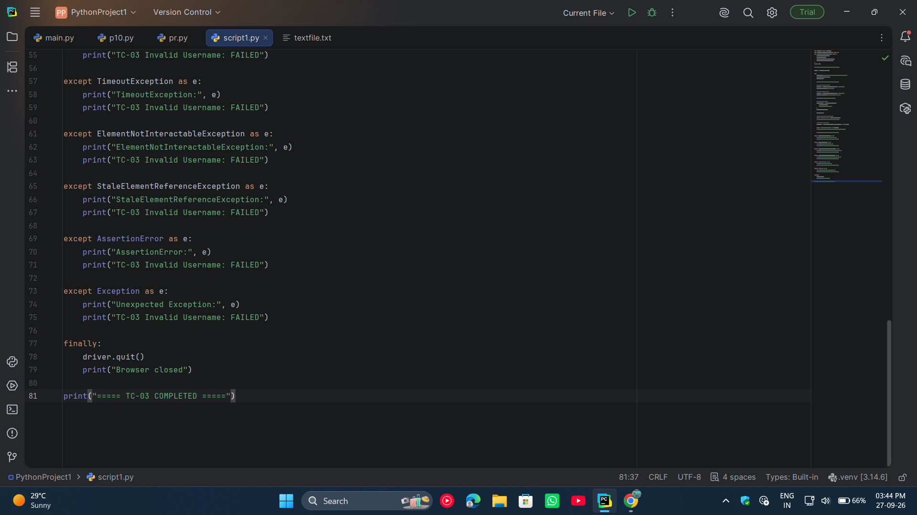
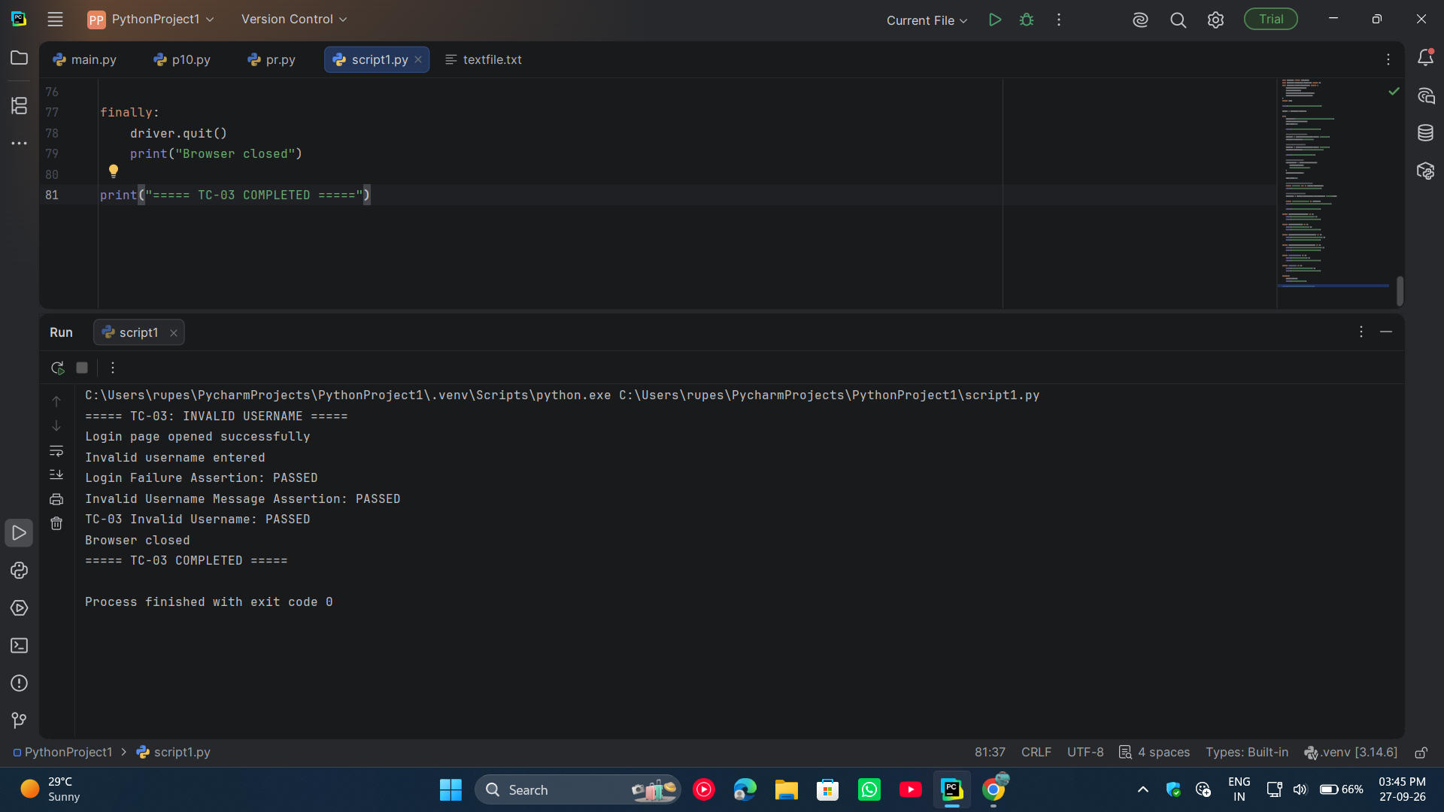

● Scenario ID: 15d
Scenario: Empty Credentials
Test Steps:
- Open PyCharm.
- Open the Practical 15 project.
- Create a new Python file named script4.py.
- Import Selenium WebDriver and the required exception classes.
- Create a Chrome WebDriver object.
- Open the Expand Testing Login Page.
- Maximize the browser window.
- Locate the Username field using its ID.
- Keep the Username field empty.
- Locate the Password field using its ID.
- Keep the Password field empty.
- Verify that both fields require input before form submission.
- Click the Login button without entering any credentials.
- Verify that the browser does not navigate to the secure page.
- Verify that the Username and Password fields remain available.
- Display the validation results in the PyCharm console.
- Handle Selenium and assertion exceptions using try-except.
- Close the browser using driver.quit().
- Record the test result as PASS when login is prevented with empty credentials.
Screenshots: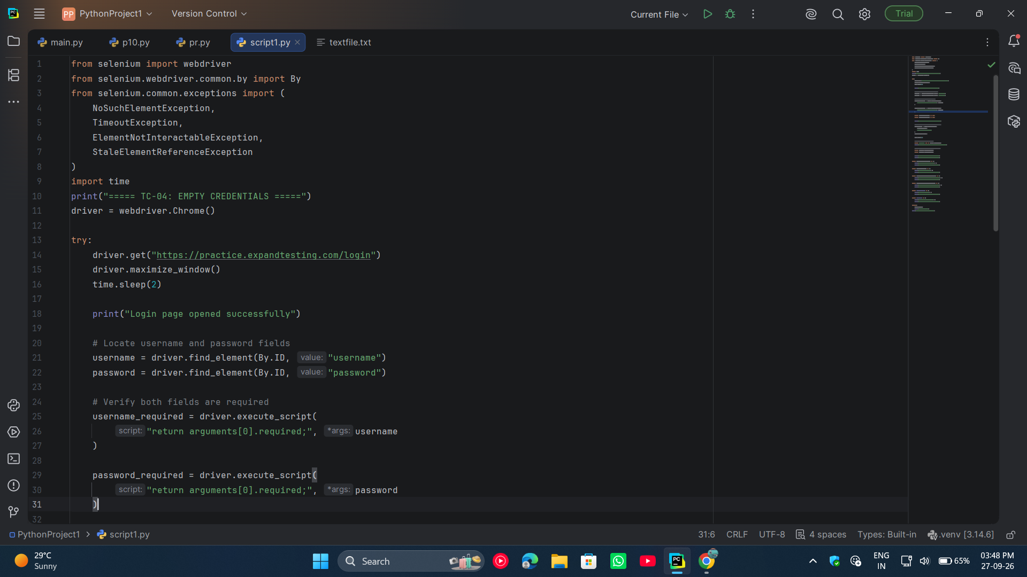

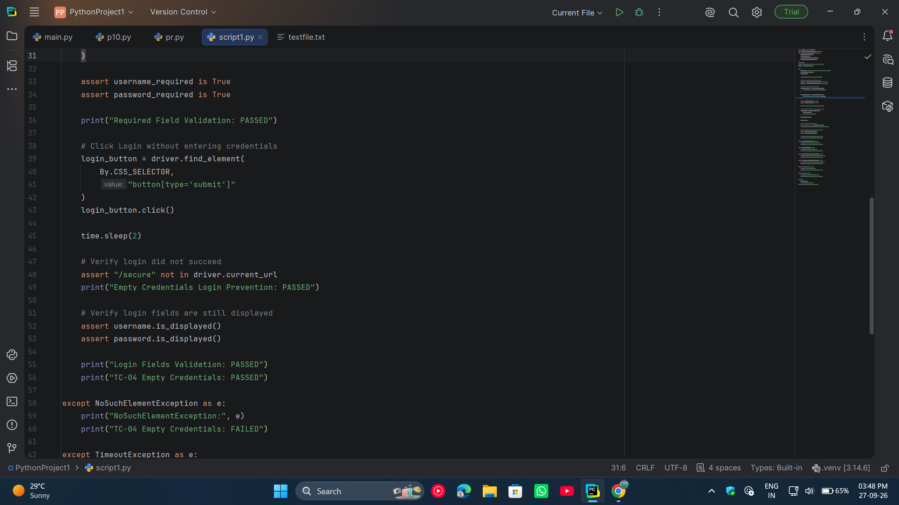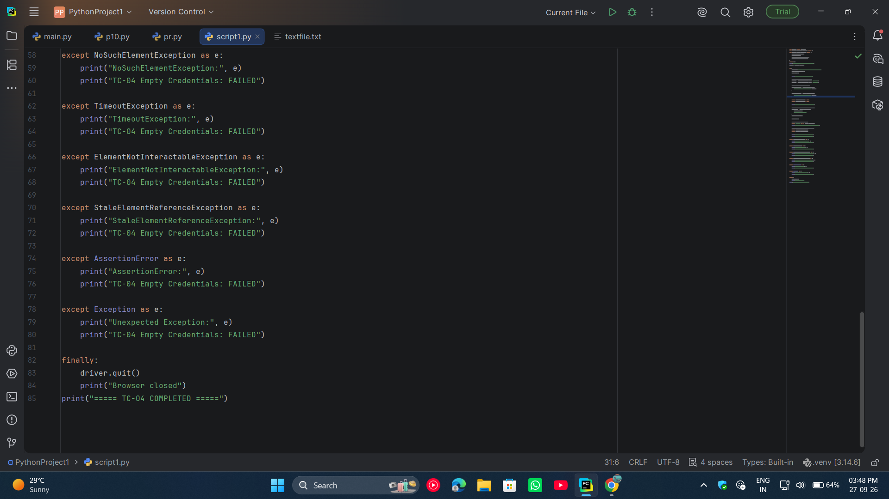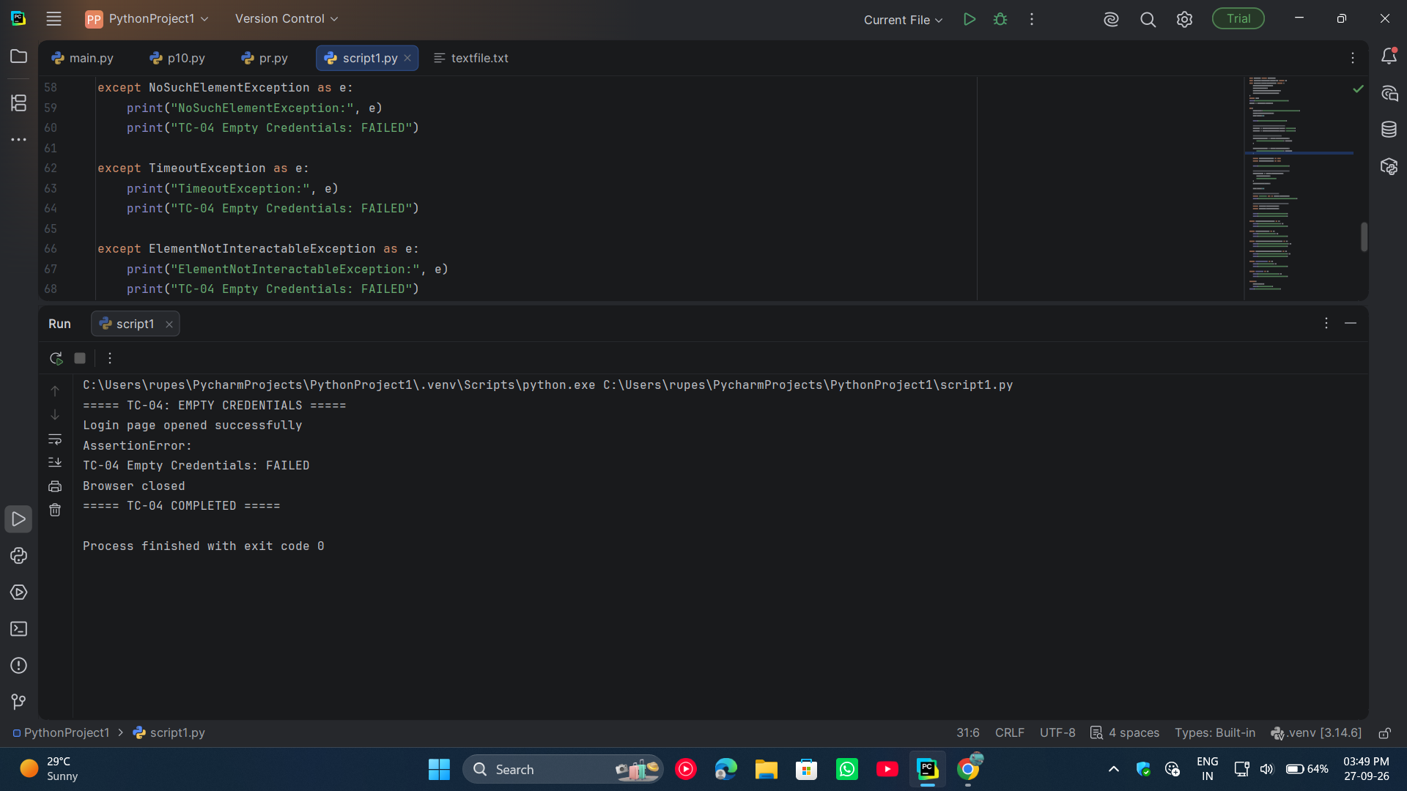
● Scenario ID: 15e
Scenario: Logout
Test Steps:
- Open PyCharm.
- Open the Practical 15 project.
- Create a new Python file named script5.py.
- Import Selenium WebDriver and the required exception classes.
- Create a Chrome WebDriver object.
- Open the Expand Testing Login Page.
- Maximize the browser window.
- Locate the Username field using its ID.
- Enter the valid username practice.
- Locate the Password field using its ID.
- Enter the valid password SuperSecretPassword!.
- Locate and click the Login button.
- Wait for the secure page to load.
- Verify that the secure page is displayed.
- Locate the Logout button.
- Click the Logout button.
- Wait for the login page to load again.
- Verify that the user is no longer on the secure page.
- Verify that the Username field is displayed again.
- Verify that the Password field is displayed again.
- Display the assertion results in the PyCharm console.
- Handle Selenium and assertion exceptions using try-except.
- Close the browser using driver.quit().
- Record the test result as PASS.
Screenshots: